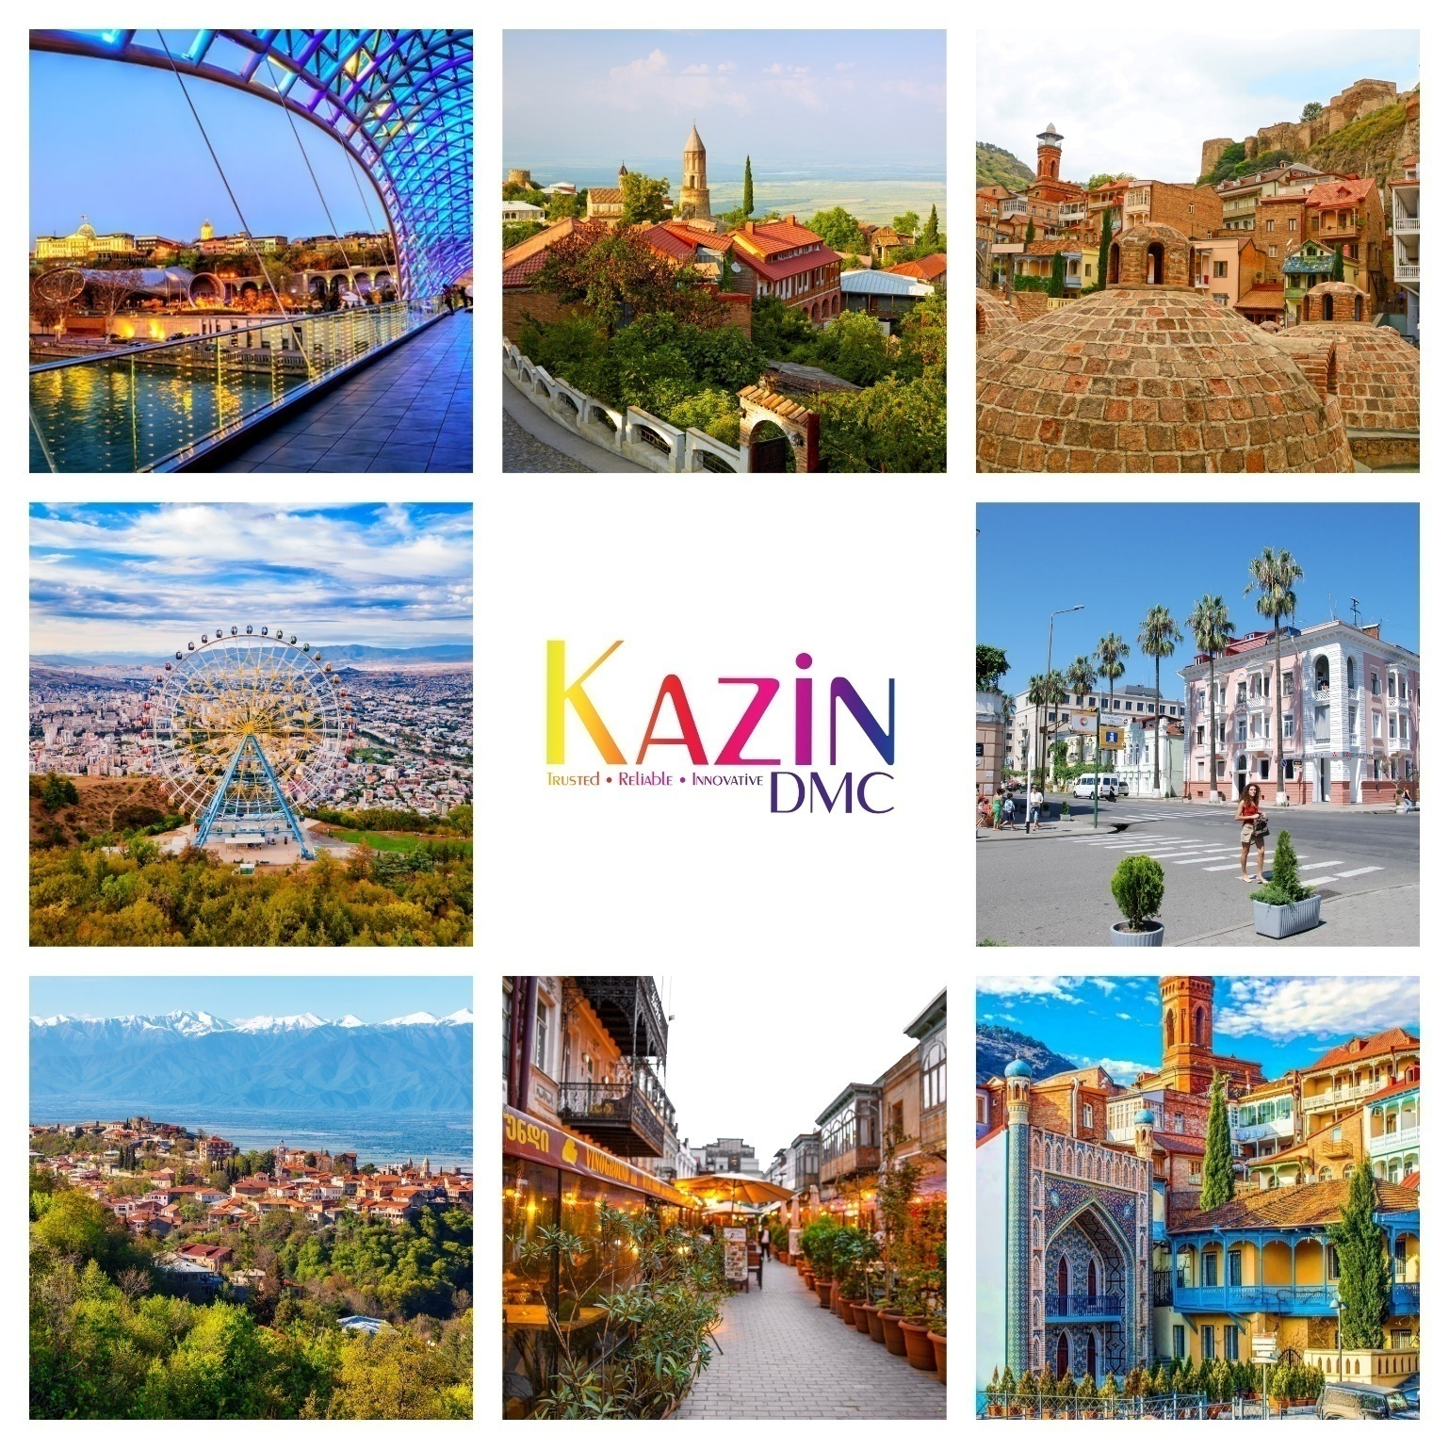
We Love Georgia
7Nights/8Days
NVC-FIT-B2B-2024
Validity: 1stJan 2024 – 30thDec 2024

DAY 01 |  | WELCOME TO TBILISI
2400 Hrs |  | Arrival to Tbilisi International Airport. After immigration & baggage collection formalities, Meet & greet by our representative at the airport. After a warm welcome, proceed to the hotel in your comfortable vehicle.
0100 Hrs |  | You will be escorted to your vehicle. Chocolates & refreshing napkins will be served on board your vehicle. Enjoy complimentary Wi-Fi on board your vehicle. Please ask your guide for login details.
0200 Hrs |  | Welcome to your hotel & check-in to your room. & Overnight Stay At the Hotel.
 | Day 2 |  | FULL DAY TBILISI CITY TOUR
 |  |  | Breakfast at the hotel
 | 1000 Hrs |  | After breakfast our driver guide will pick you up from the hotel.  Today you will have a city tour in the capital of Georgia - Tbilisi which is considered as one of the most ancient cities in the Caucasus.  Tbilisi for city tour where you can take cable car/ropeway to Narikala Fortress to enjoy breathtaking panoramic view of the city. Walk down to the district of Sulphur bath houses passing by the only mosque in Tbilisi. You will stroll through the Shardeni area - full of narrow streets with cozy cafés, wine tasting bars, souvenir shops, and breathe in the living past. You are able to visit Anchiskhati Basilica and the clock tower of famous Rezo Gabriadze Theatre;.
 | 1400 Hrs. |  | Lunch at Indian/Local restaurant. (Direct Payment)
 | 1500 Hrs. |  | Free time for shopping
 | 2000 Hrs. |  | Dinner at Indian/Local restaurant. (Direct Payment)
 |  |  | Overnight stay at the HOTEL in tbilisi.

Day 4 | MTSKHETA-GORI-UPLISTSIKHE
0700-1000Hrs. | Breakfast at the hotel.
1000 Hrs. | Our driver will pick you up from the hotel.  First stop will be Mtskheta - one of the oldest towns and the cultural and religious centre of Georgia. The former capital of Georgia has some outstanding examples of mediaeval religious architecture. Named a UNESCO World Heritage Site in 1994. The site is believed to have been settled since around 3000-2000 BC. Its mild climate and its fertile soil together with its strategic location at the confluence of the Aragvi and Mtkvari rivers made it an ideal home for human habitation. It also became an important stopping point on the ancient trade routes and was a significant site of early Christian activity. Mtskheta was the capital of the early Georgian Kingdom of Iberia, from the 3rd century BC until the 5th century AD. At the beginning of the 6th century, King Dachi I Ujarmeli moved the capital from Mtskheta to Tbilisi, in accordance with his father’s will. You will see Jvari Monastery and Svetitskhoveli Cathedral.
1400 Hrs. | Lunch at Indian/Local restaurant. (Direct Payment)
1500 Hrs. | After that continue the tour to Joseph Stalin's Museum in Gori, established as a local history museum but clearly intended to become a memorial to Stalin. The main building of the complex is a large palace in Stalinist Gothic style. Enshrined within a Greco-Italianate pavilion is a small wooden hut, in which Stalin was born in 1878 and spent his first four years.
 | Next stop is Uplistsikhe (literally, “the lord’s fortress”) -Spend a day exploring some of the most fascinating attractions in Georgia, starting with the ancient town of Uplistsikhe, considered once of the oldest urban settlements in all of George and dating back to the 200 B.C. The ancient rock-hewn town, on the list for inclusion into the UNESCO World Heritage program, contains a bulk of rock-cut structures and is connected to the southern part via a narrow rock-cut pass and a tunnel, with narrow alleys and sometimes staircases radiating from the central "street" to its various structures. Transfer back to hotel
2000 Hrs. | Dinner at Indian/Local restaurant. (Direct Payment)
 | Overnight stay at the HOTEL in tbilisi.

Day 4 |  | Ananuri & Gudauri tour
0700-1000Hrs. |  | Breakfast at the hotel
1000 Hrs |  | Our driver will pick you up at your hotel. The route will take over the Georgian Military Highway up North towards the border with Russia;  Your first stop will be at Ananuri fortress which is a sixteenth century castle complex on the Aragvi River. The fortress stands beside the famous Georgian Military Highway, overlooking a large Jinvali lake. Its high, turreted stone walls protect two churches, a watch tower and a reservoir. The main church facade is beautifully carved with animal, floral and Celtic style patterns;
1200 Hrs. |  | Next Stop is Gudauri – young and rapid developing winter sports resort located at Kazbegi region of Georgia, 120 km from Tbilisi, at the height of 2,196 m (about 7,200 feet) near the Cross Pass. Skiing season lasts from December to April. In summer Gudauri is calm. Green environment, cool weather and clean air make a positive impact on the general health condition of people.
1400 Hrs. |  | Lunch at Indian/Local restaurant. (Direct Payment)
1500 Hrs. |  | After that drive to Gergeti Trinity Church - At an altitude of 7119 feet (2,170 meters), the twelfth or thirteenth century monument was erected on the southern slopes of Mkinvarcveri. Gergeti Trinity Church is an important temple, remarkable for its beautiful scenery. The Gergeti Trinity Church is set poignantly on a hill directly below the towering white massif of Mount Kazbek, which sits at 5,033 meters. Built six hundred years ago, its stones have weathered repeated blizzards, rain and invasion to stand as a proud symbol of Georgian resilience in the face of adversity. It is the photographer’s perfect shot.
 | 2000 Hrs |  | Dinner at Indian/Local restaurant. (Direct Payment)
 |  |  | Overnight stay at the HOTEL in Kazbegi

Day 5 | STEPANTSMINDA, GERGETI CHURCH
0700-1000Hrs. | Breakfast at the hotel
1000 Hrs | After that drive to Gergeti Trinity Church - At an altitude of 7119 feet (2,170 meters), the twelfth or thirteenth century monument was erected on the southern slopes of Mkinvarcveri. Gergeti Trinity Church is an important temple, remarkable for its beautiful scenery. The Gergeti Trinity Church is set poignantly on a hill directly below the towering white massif of Mount Kazbek, which sits at 5,033 meters. Built six hundred years ago, its stones have weathered repeated blizzards, rain and invasion to stand as a proud symbol of Georgian resilience in the face of adversity. It is the photographer’s perfect shot.
1300 Hrs. | Back to Kazbegi
1400 Hrs. | Lunch at Indian/Local restaurant. (Direct Payment)
2000 Hrs | Dinner at Indian/Local restaurant. (Direct Payment)
 | Overnight stay at the HOTEL in Kazbegi

Day 6 | Kakheti region Telavi City
0700-1000Hrs. | Breakfast at the hotel
1000 Hrs | Our driver will pick you up at your hotel. The route will take from north to east.  We will drive towards Kakheti region.  Kakheti is declared as birthplace of wine.
1300 Hrs. | Arrive in Telavi & visit Tsinandali. Prince alexander’s estate.
1400 Hrs. | Lunch at Indian/Local restaurant. (Direct Payment)
1600 Hrs. | Check in hotel & evening leisure
2000 Hrs | Dinner at Indian/Local restaurant. (Direct Payment)
 | Overnight stay at the HOTEL in Telavi

Day 7 |  | Bodbe & Sighnagi tour
 | 0700-1000Hrs. |  | Breakfast at the hotel
 | 1000 Hrs |  | Our driver will pick you up at your hotel.  Today you will visit Sighnagi – city of love, surrounded by the longest wall after Chinese great wall. City was used as a shelter for villagers around Sighnagi, during enemy’s attack, all citizens were approaching Sighnagi and fighting back from there. City is modernized and offering too much to tourists. Scenic views of Caucasus Mountain and reach history.
 | 1300 Hrs. |  | Arrive in Sighnagi & walking tour
 | 1400 Hrs. |  | Lunch at Indian/Local restaurant. (Direct Payment)
 | 1600 Hrs. |  | Continue towards Bodbe monastery, Bodbe is dedicated to St Nino, the enlightener of Georgia.
 | 2000 Hrs |  | Dinner at Indian/Local restaurant. (Direct Payment)
 |  |  | Overnight stay at the HOTEL in Telavi

Day 8 | Departure transfer
- After breakfast check out & proceed towards Tbilisi airport
- Drop off in airport
Bon voyage

PRICE GRID (Non-Visa Countries-2024) Updated 1st March 2024

7N –Best of Georgia | 3 n Pine Astoria | 2 N Suatis resort Kazbegi | 2 N Holiday Inn Telavi | Supplement cost  For period 1st May – 30th October (Peak Season)
Category | 5* | 4* | 4*
2 Pax | 575 |  |  | U$ 40 pp
4 Pax | 465 |  |  | U$ 40 pp
6 Pax | 497 |  |  | U$ 40 pp
8 Pax | 475 |  |  | U$ 40 pp
10 Pax | 432 |  |  | U$ 40 pp
12 Pax | 395 |  |  | U$ 40 pp
14 Pax | 378 |  |  | U$ 40 pp
16 Pax | 360 |  |  | U$ 40 pp
Single Sup | 180 |  |  | U$ 40 pp
CNB (6-11) | 235 |  |  | U$ 40 pp
CWB (6-11) | Double – 7%

INCLUSIONS
- Airport meet & greet.  - Chocolates & refreshing napkins served on board your vehicle.  - Complimentary Wi-Fi on board all our vehicles.  - 7 nights stay as per choice of hotels mentioned above.  - Daily breakfast.  - Dedicated English speaking guide (for groups 6 & more pax)  - Souvenir upon departure courtesy Kazin Dmc. | - Dedicated private vehicle with driver throughout the trip.  - Vehicle & guide at disposal daily for 12 hours  (1000 hrs – 2200 hrs)  - Entrance fees- Tbilisi Cable car  - Jeep ride in Kazbegi  - Wine tasting in Kakheti  - 2 bottles of water daily per person.  - Hotel taxes.

EXCLUSIONS | NOTES
- Expenses of personal nature  - Meals (unless or otherwise specified)  - GST & TCS (For India only)  - Visa  - Flights | - Given rate is for specific hotels– if hotels will be changed rate is subject to change as well.  - Rates are per person on sharing a room basis.  - Above is a sample price and is subject to availability & currency fluctuation.  - Package is based on flight 6E-1807/6E-1808. Ex. Delhi.  - Package prices are not valid on black-out/exhibition dates.  - Given rate is for specific hotels– if hotels will be changed rate is subject to change as well.  - Quoted tour prices are based on current rates of exchange, tariffs and taxes. We reserve the right to increase tour prices to cover increased costs of tariffs, taxes, park fees and fluctuations in foreign exchange markets.  - Pax travelling together of a group on the same time will be calculated as one transfer for arrival and departure. Pax travelling on different timings of the same group for arrivals and departures will be calculated as additional transfers and, in that case, price is subject to change according to transfer quantity.
